Asian Parliament Working Group 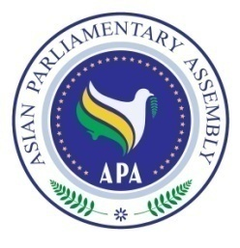
Questionnaire

- What model for Asian Parliament do you propose?
- Forum and advisory nature? b) Executive characteristic?

- Should the legislations of “Asian Parliament” be compulsory or optional to Member Parliaments?

If they are compulsory, it means Member Parliaments should delegate Asian Parliament to decide and adopt some legislations on their behalf and Member Parliaments must be committed to those legislations and re-adopt such legislations as their internal and national law and regulations. Are you available to re-adopt such legislations?

If the legislations or resolutions are optional then in your opinion what is the difference between such Asian Parliament and Asian Parliamentary Assembly?

- Do you think the forming of working group is productive and can fulfill the task of the discussion of Asian Parliament?

- Do you like to nominate one permanent representative for the participation in working group? If yes, please indicate the name and the contact & email address.

